ONEWAY ACC BY Temp
/STATISTICS DESCRIPTIVES HOMOGENEITY WELCH
/PLOT MEANS
/MISSING ANALYSIS.

Oneway

Notes
Output Created |  | 05-May-2019 23:54:09
Comments
Input | Active Dataset | DataSet0
Input | Filter | <none>
Input | Weight | <none>
Input | Split File | <none>
Input | N of Rows in Working Data File | 30
Missing Value Handling | Definition of Missing | User-defined missing values are treated as missing.
Missing Value Handling | Cases Used | Statistics for each analysis are based on cases with no missing data for any variable in the analysis.
Syntax |  | ONEWAY ACC BY Temp  /STATISTICS DESCRIPTIVES HOMOGENEITY WELCH  /PLOT MEANS  /MISSING ANALYSIS.
Resources | Processor Time | 00 00:00:00.172
Resources | Elapsed Time | 00 00:00:00.164

[DataSet0]

Descriptives
ACC
 | N | Mean | Std. Deviation | Std. Error
Between 22°C-18°C | 9 | 93.1111 | 20.64851 | 6.88284
Between 24°C-26°C | 6 | 101.8333 | 29.15762 | 11.90355
In between 24°C and 22°C | 13 | 98.3846 | 25.95682 | 7.19913
Less than 18°C | 2 | 58.5000 | 12.02082 | 8.50000
Total | 30 | 94.8333 | 25.60722 | 4.67522

Descriptives
ACC
 | 95% Confidence Interval for Mean |  | Minimum | Maximum
 | Lower Bound | Upper Bound | Minimum | Maximum
Between 22°C-18°C | 77.2393 | 108.9830 | 71.00 | 123.00
Between 24°C-26°C | 71.2343 | 132.4324 | 57.00 | 128.00
In between 24°C and 22°C | 82.6991 | 114.0702 | 63.00 | 150.00
Less than 18°C | -49.5027 | 166.5027 | 50.00 | 67.00
Total | 85.2714 | 104.3952 | 50.00 | 150.00

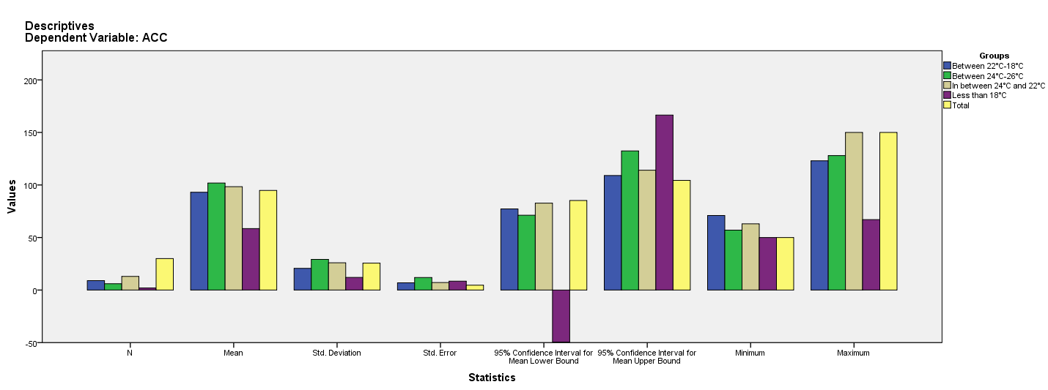

Test of Homogeneity of Variances
ACC
Levene Statistic | df1 | df2 | Sig.
1.319 | 3 | 26 | .290

ANOVA
ACC
 | Sum of Squares | df | Mean Square | F | Sig.
Between Groups | 3124.868 | 3 | 1041.623 | 1.704 | .191
Within Groups | 15891.299 | 26 | 611.204
Total | 19016.167 | 29

Robust Tests of Equality of Means
ACC
 | Statisticª | df1 | df2 | Sig.
Welch | 4.356 | 3 | 5.890 | .061
a. Asymptotically F distributed.

Means Plots

